**Implementation of Root Locus using Sisotool in MATLAB**

**Lab#11**

Submitted by**:**

**Maaz Habib**

Registration Number**:**

**20PWCSE1952**

Section:

**C**

Submitted To**:**

**Dr. Muniba Ashfaq**

January 31, 2024

**Department of Computer System Engineering**

**University of Engineering and Technology Peshawar**

**Objectives:**

* Finding the root locus of a system using Sisotool in MATLAB
* Understanding Sisotool feature in MATLAB

**Problem Statements:**

1. **Using sisotool find the root locus design for the following system: G(S)H(S)k(+3) (S+4)/(+5) (S+6);**
2. **Add a pair of complex poles to the system defines above.**
3. **Add a pair of complex zeros to the system defines above.**
4. **Add a real zero to the system.**
5. **Add a real pole to the system.**

**Also find the following for Questions 1 to 5.**

1. **The range of k for which the system is stable.**
2. **The break in/ breakout points if any.**
3. **The impulse response for k=2.**
4. **The step response for k=3 the rise time and peak response for k-3**
5. **Using sisotool find the root locus design for the following system: G(S)H(S)k(+3) (S+4)/(+5) (S+6);**

**MATLAB Code**

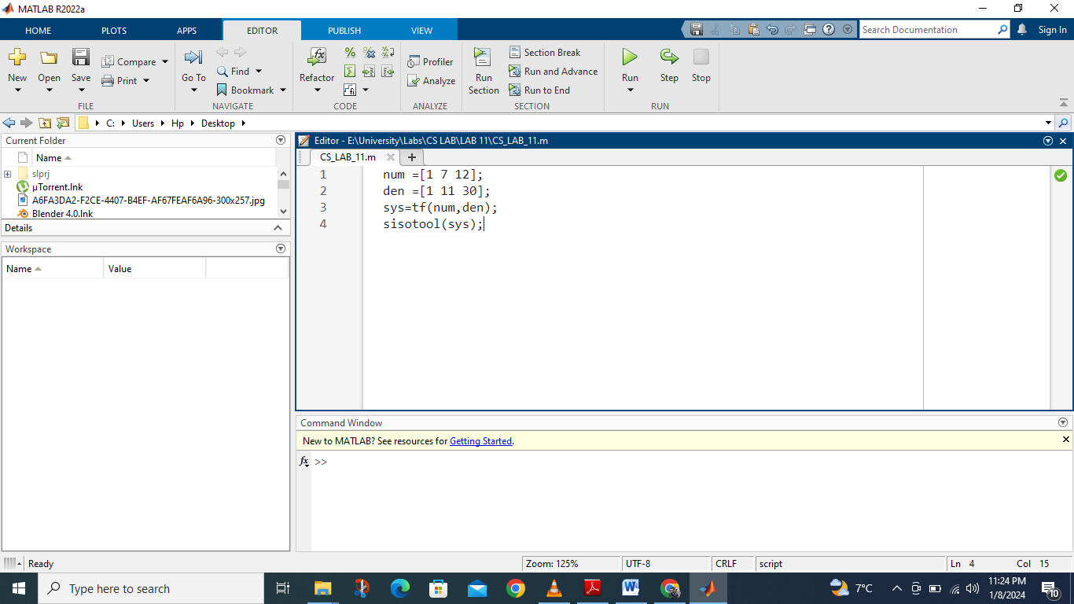

**SISO tool (Single Input Single Output)**

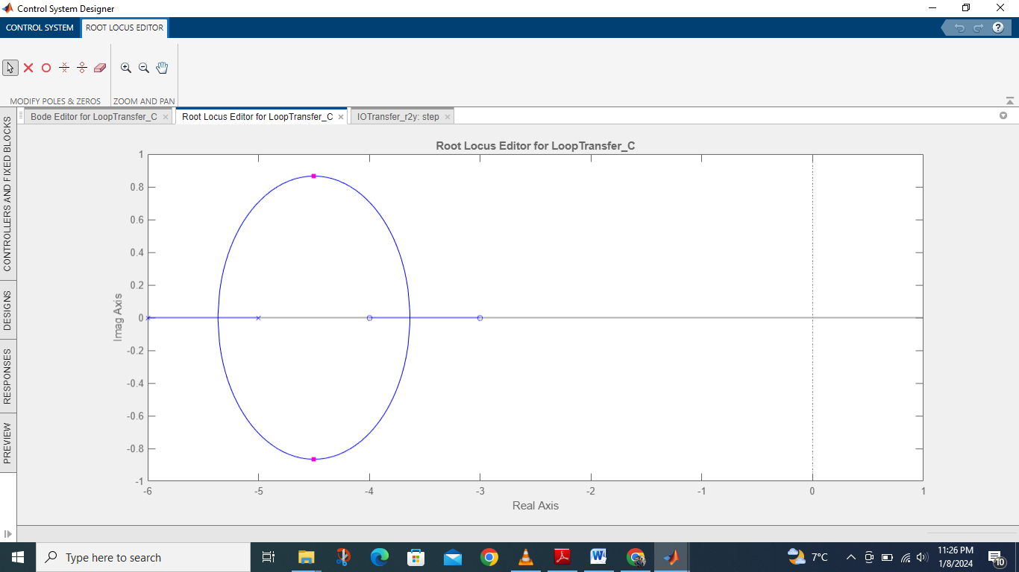

**The impulse response for k=2.**

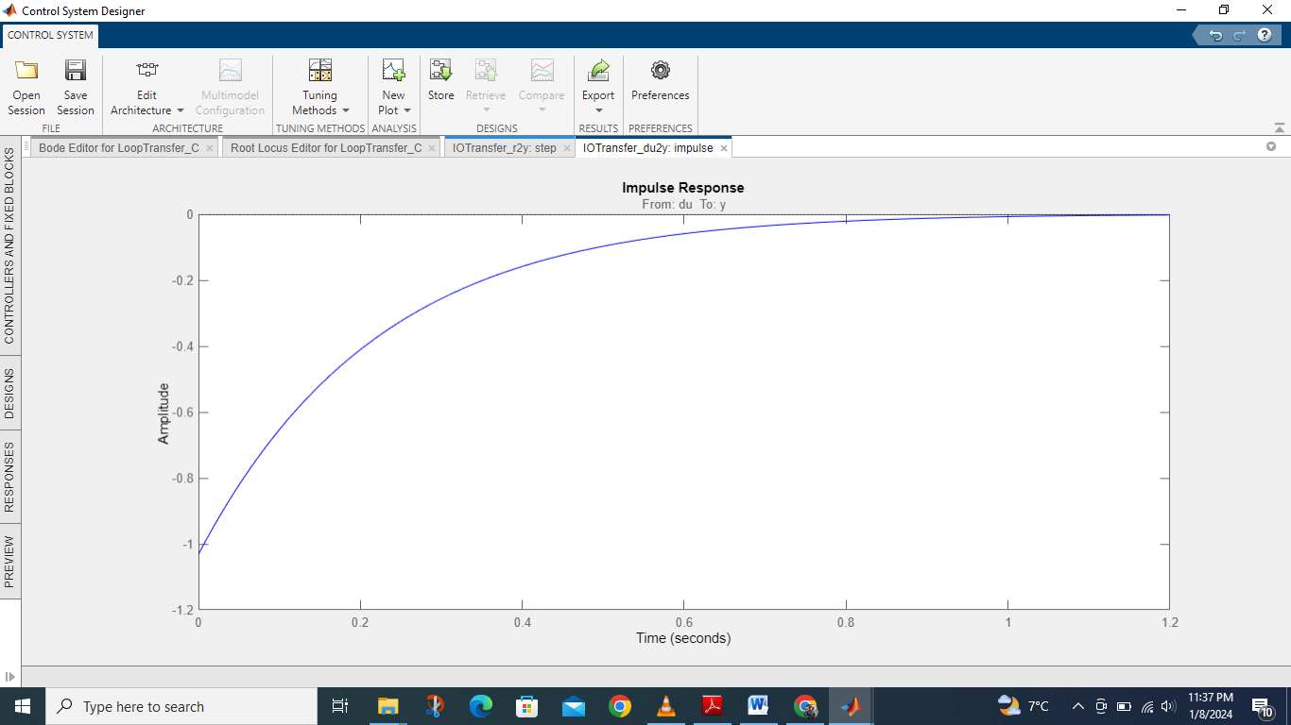

**The step response for k=3**

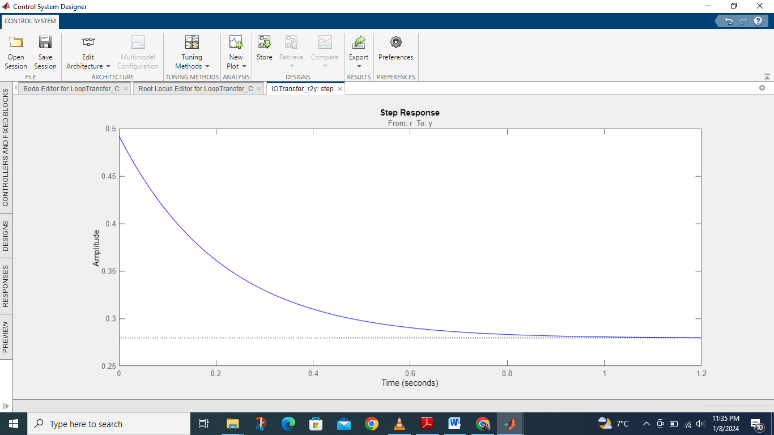

**Rise time and peak response for k=3**

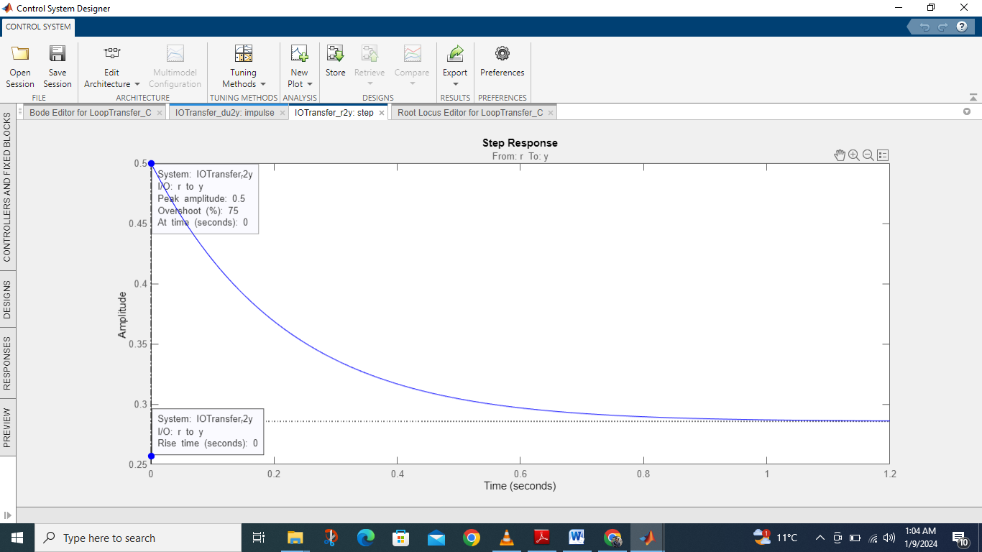

**Analysis**

* **Stability:** The system is stable for all points of k i.e. k = **-∞** to +∞
* **Breakaway Point**: 0.071
* **Break-in Point:** 2.3
* **Rise Time:** 0
* **Peak Response:** 0.5

1. **Add a pair of complex poles to the system defines above.**

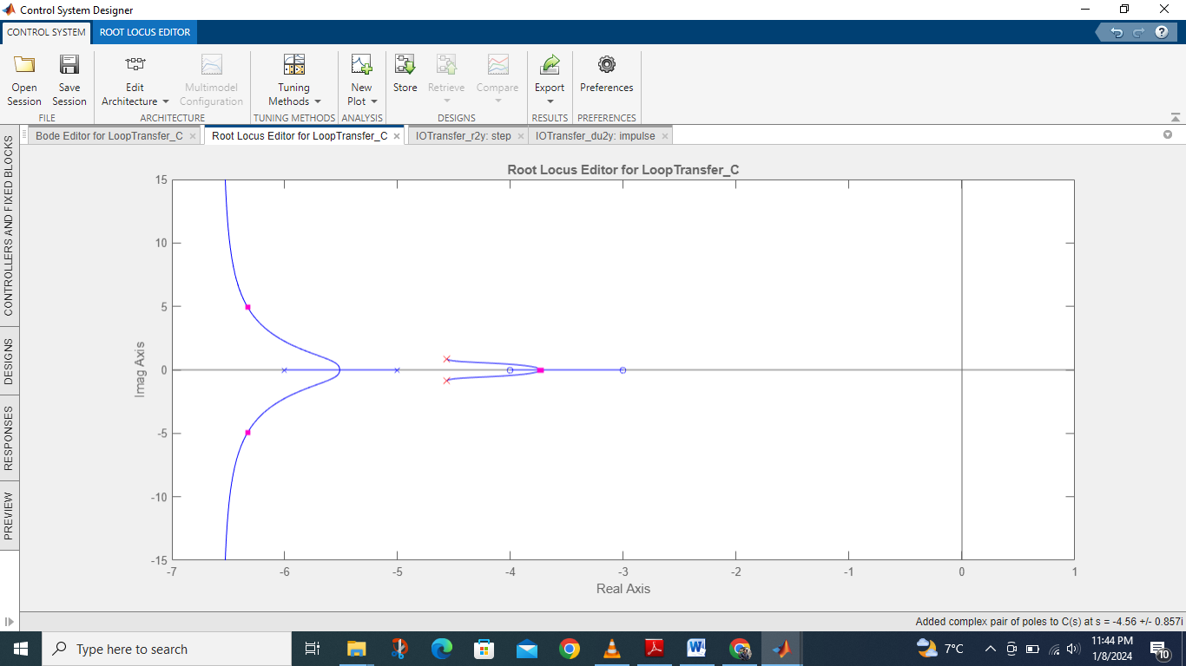

**The impulse response for k=2.**

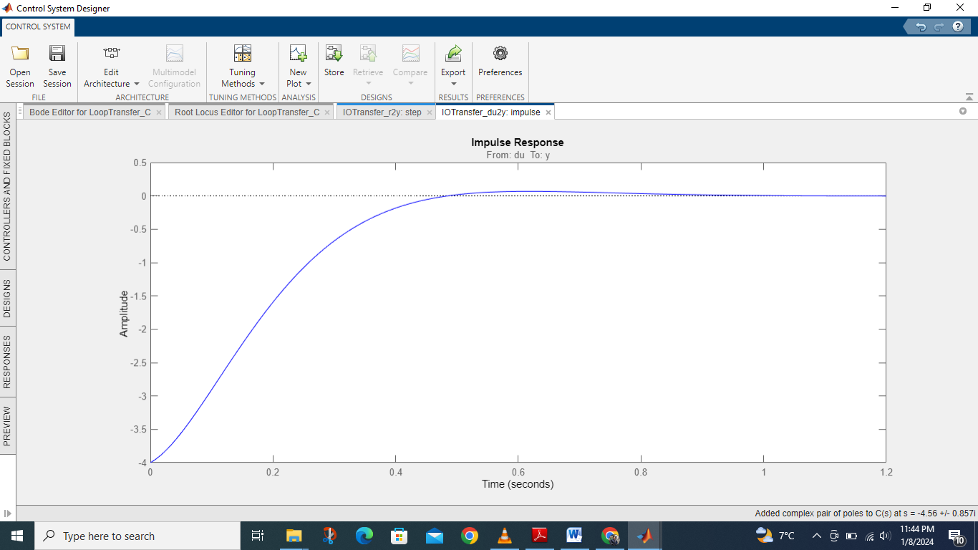

**The step response for k=3**

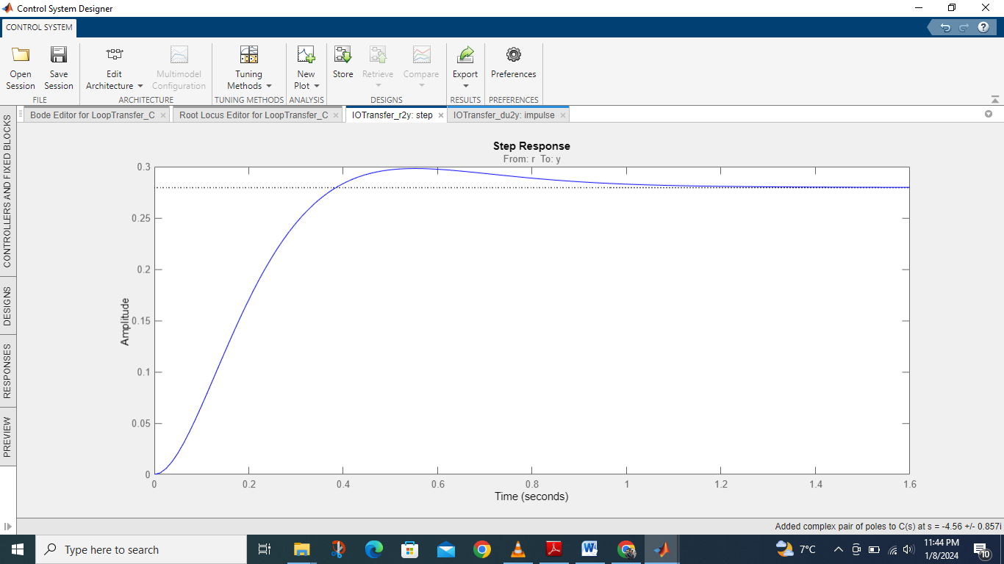

**Rise time and peak response for k=3**

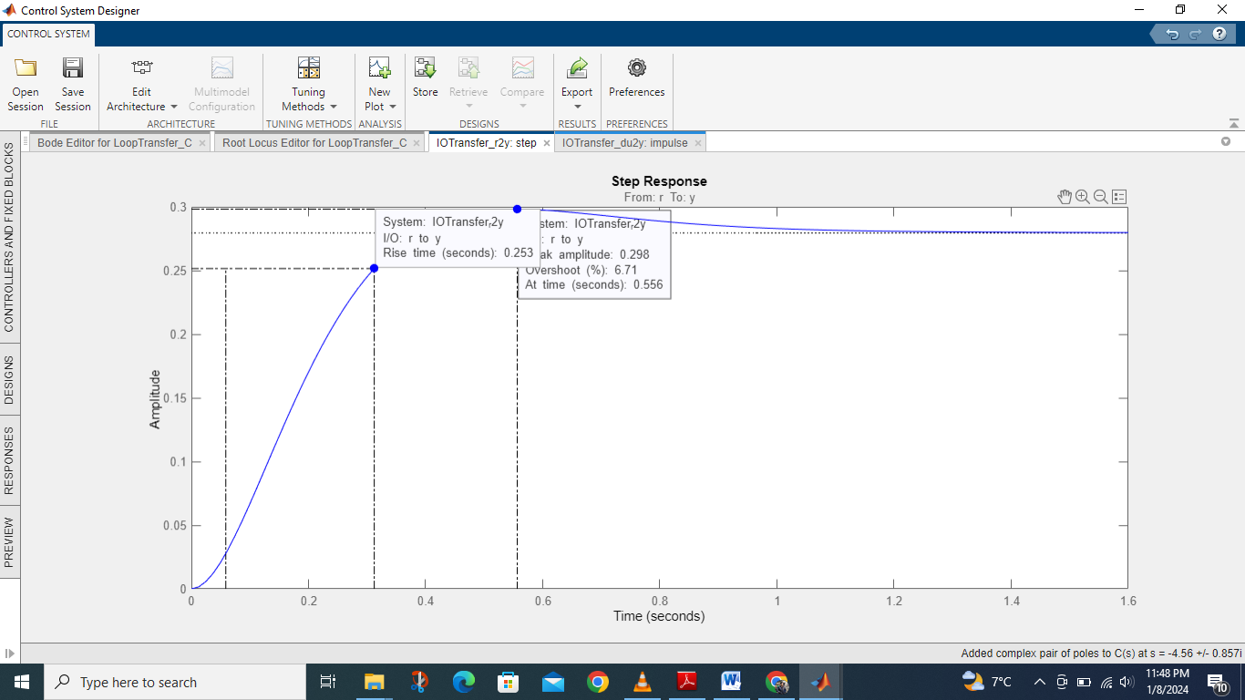

**Analysis**

* **Stability:** The system is stable for all points of k i.e. k = **-∞** to +∞
* **Breakaway Point**: 1.45
* **Break-in Point:** 3.2
* **Rise Time:** 0.253
* **Peak Response:** 0.298

1. **Add a pair of complex zeros to the system defines above.**

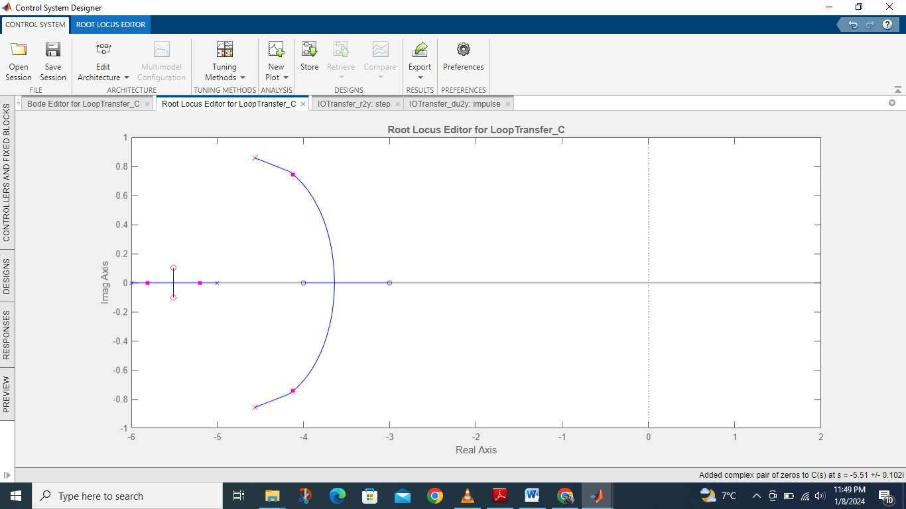

**The impulse response for k=2.**

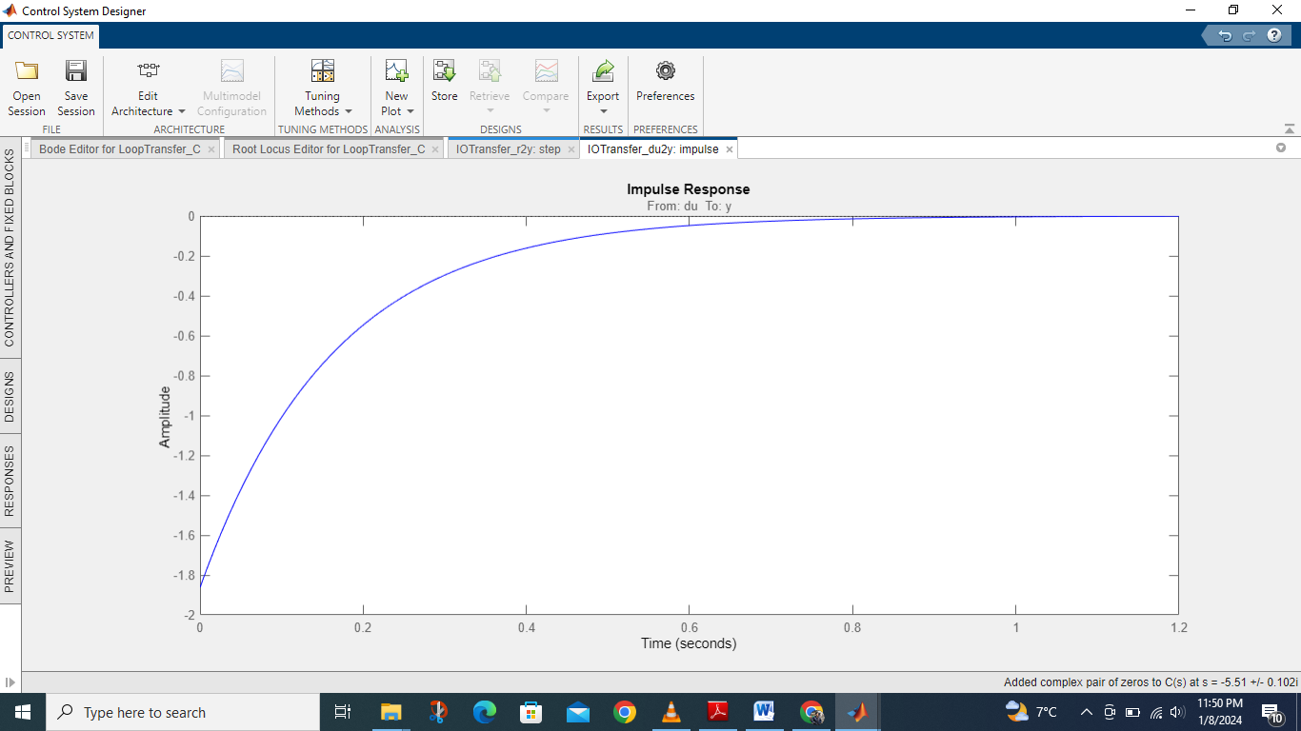

**The step response for k=3**

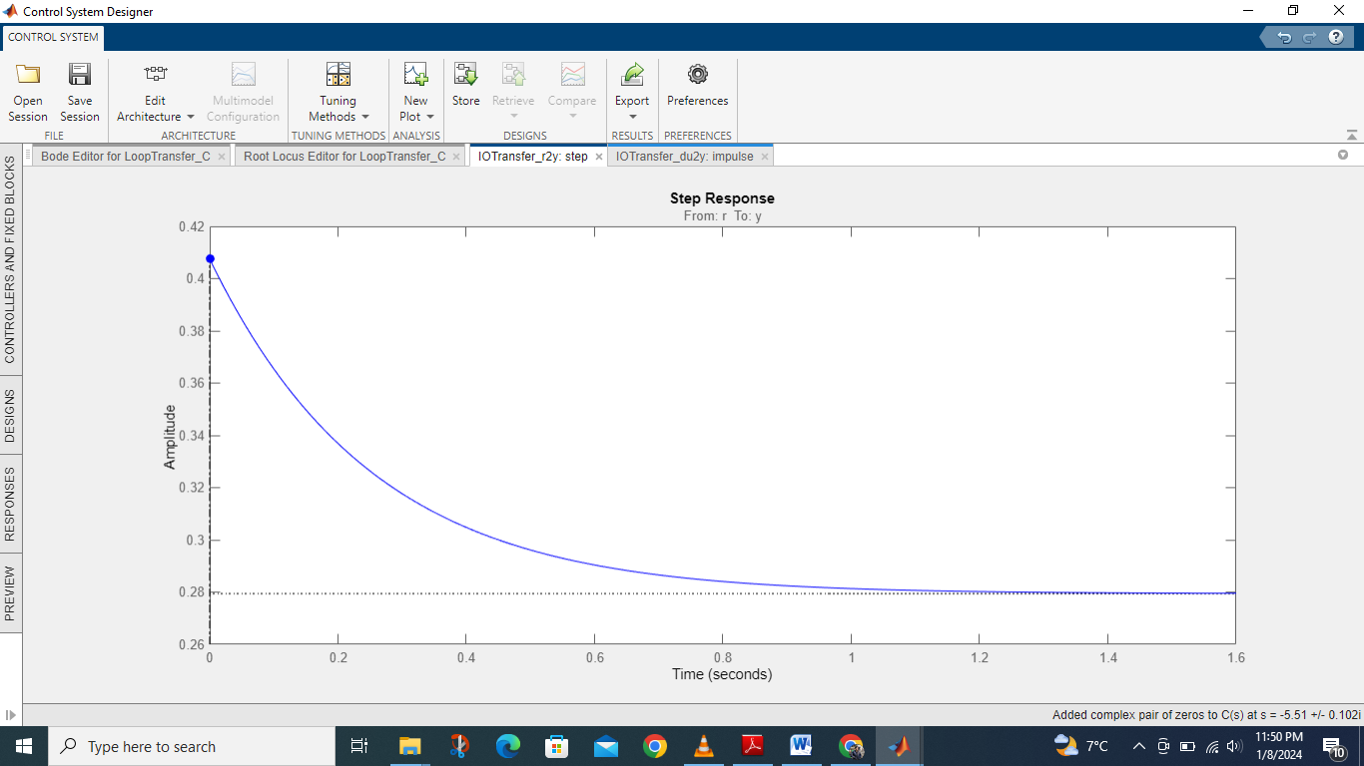

**Rise time and peak response for k=3**

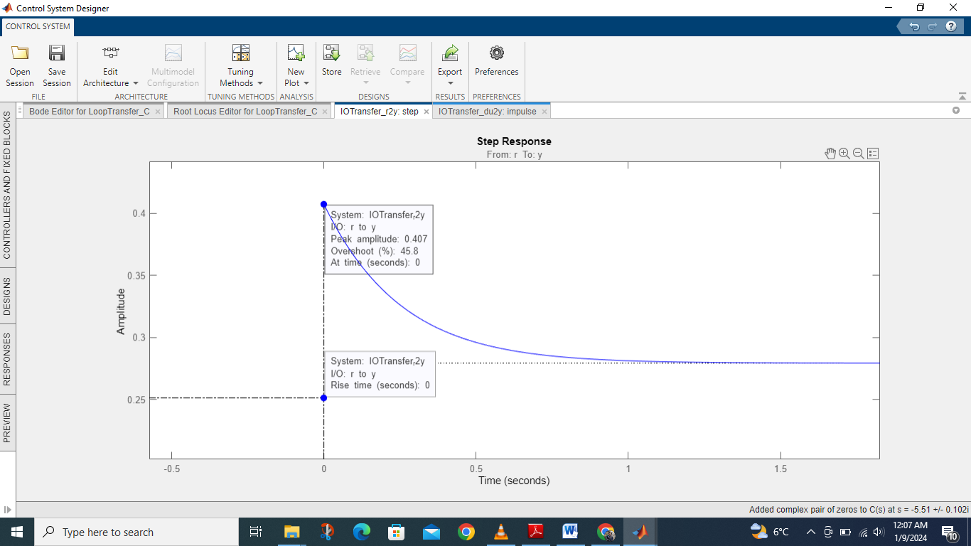

**Analysis**

* **Stability:** The system is stable for all points of k i.e. k = **-∞** to +∞
* **Breakaway Point**: 0.5
* **Break-in Point:** 2.2
* **Rise Time:** 0
* **Peak Response:** 0.407

1. **Add a real zero to the system.**

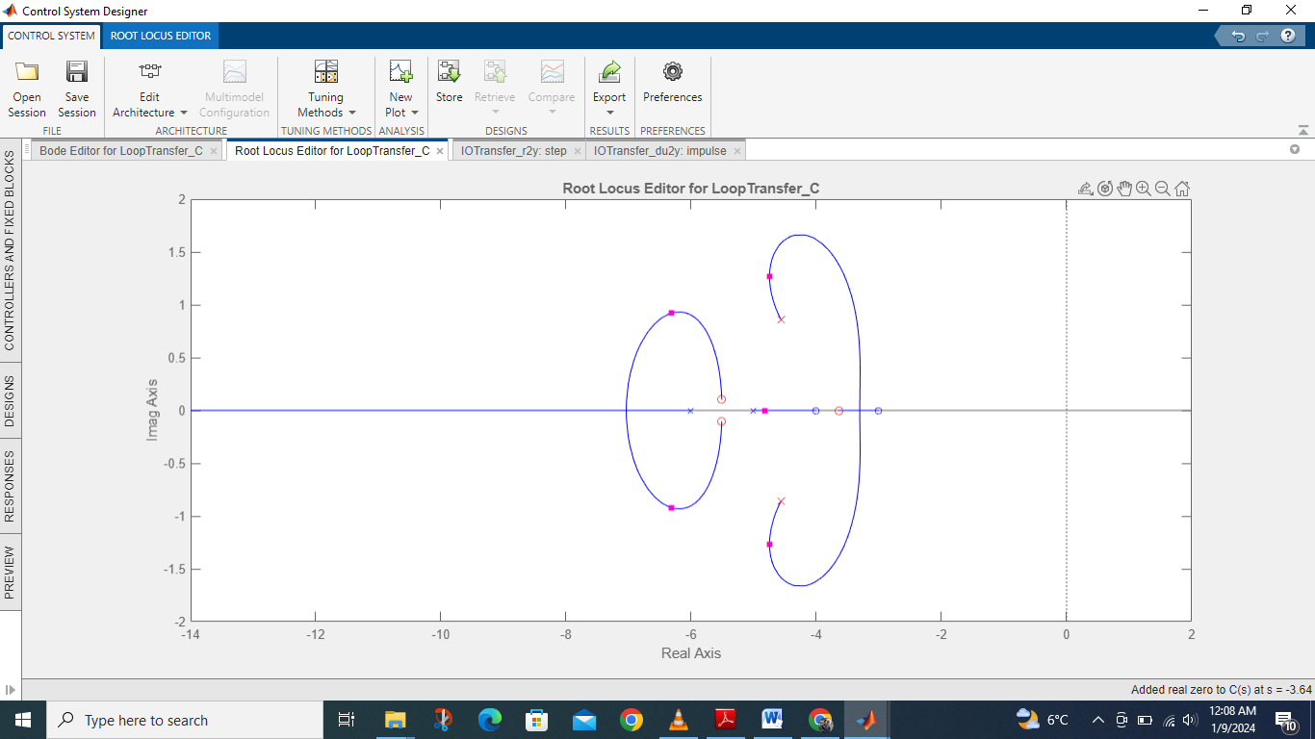

**The impulse response for k=2.**

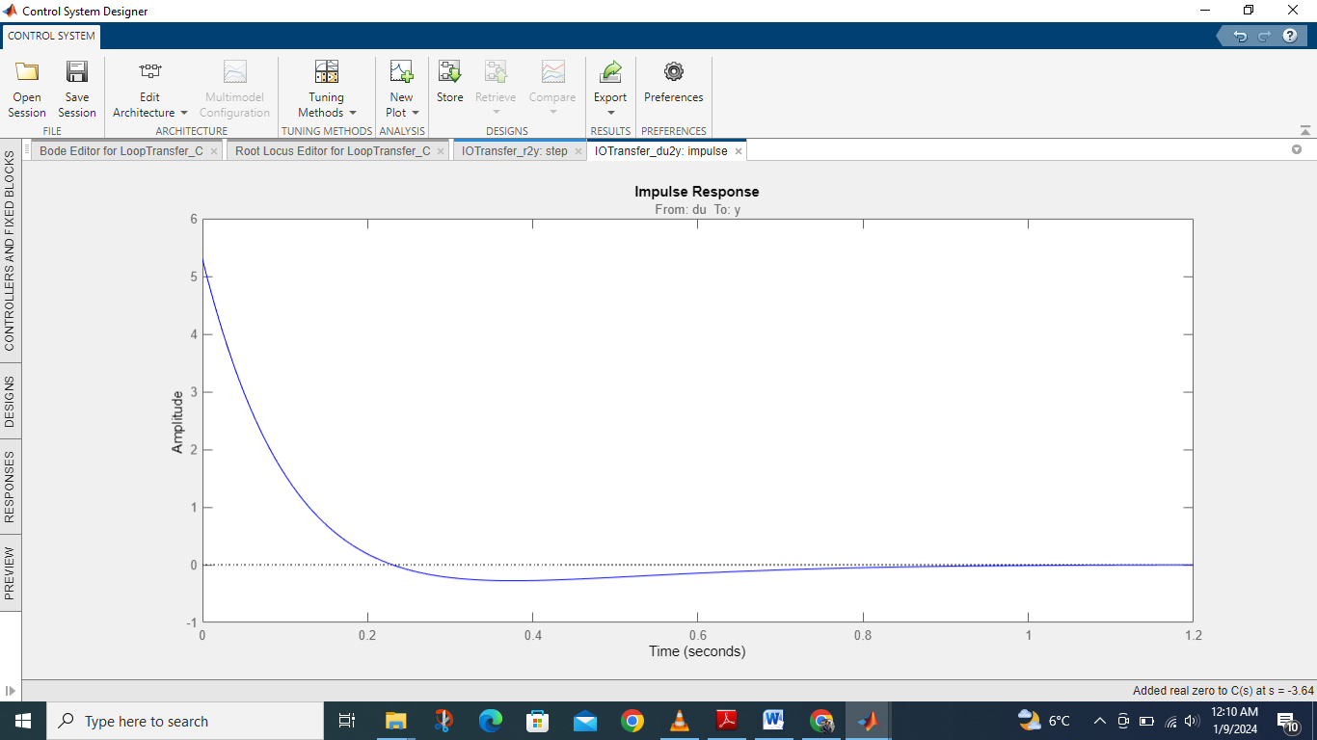

**The step response for k=3**

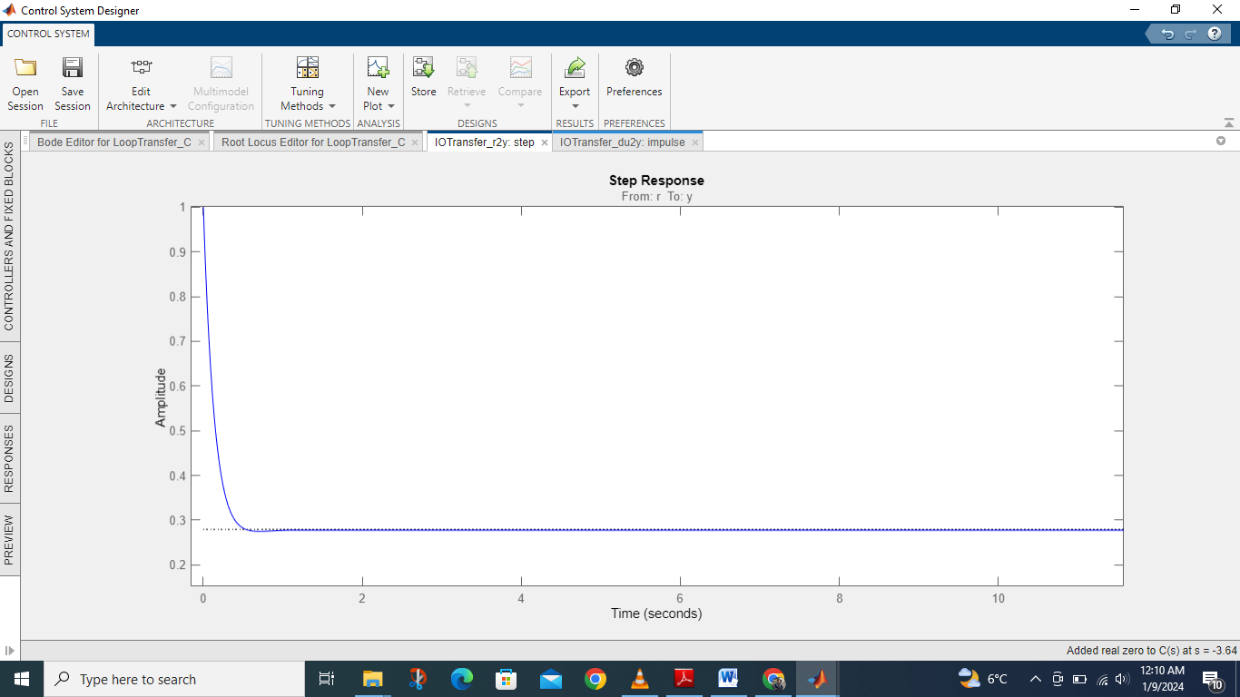

**Rise time and peak response for k=3**

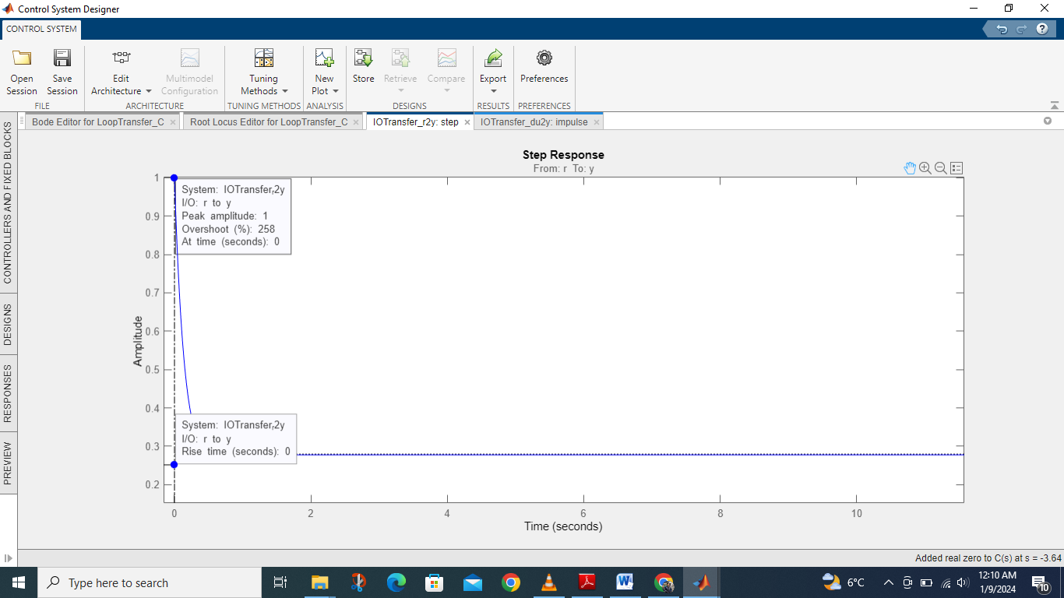

**Analysis**

* **Stability:** The system is stable for all points of k i.e. k = **-∞** to +∞
* **Breakaway Point**: 3.5
* **Break-in Point:** 5.35
* **Rise Time:** 0
* **Peak Response:** 1

1. **Add a real pole to the system.**

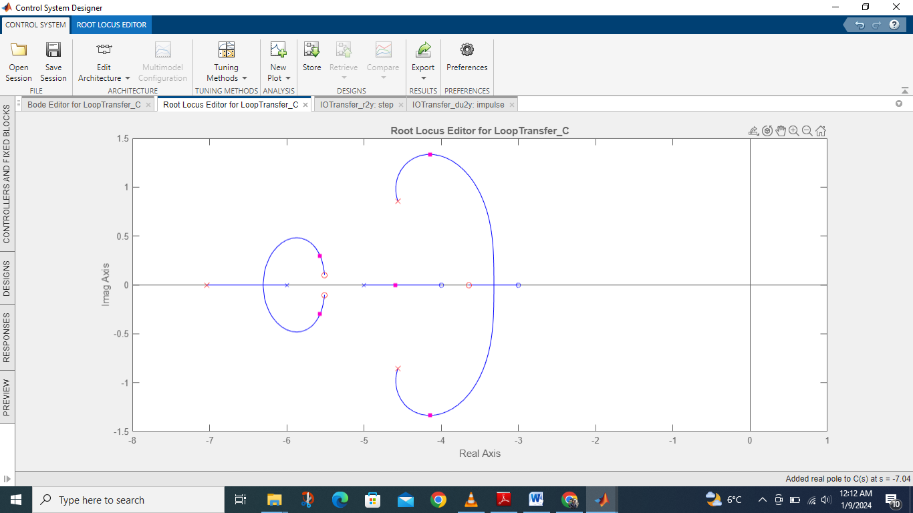

**The step response for k=3**

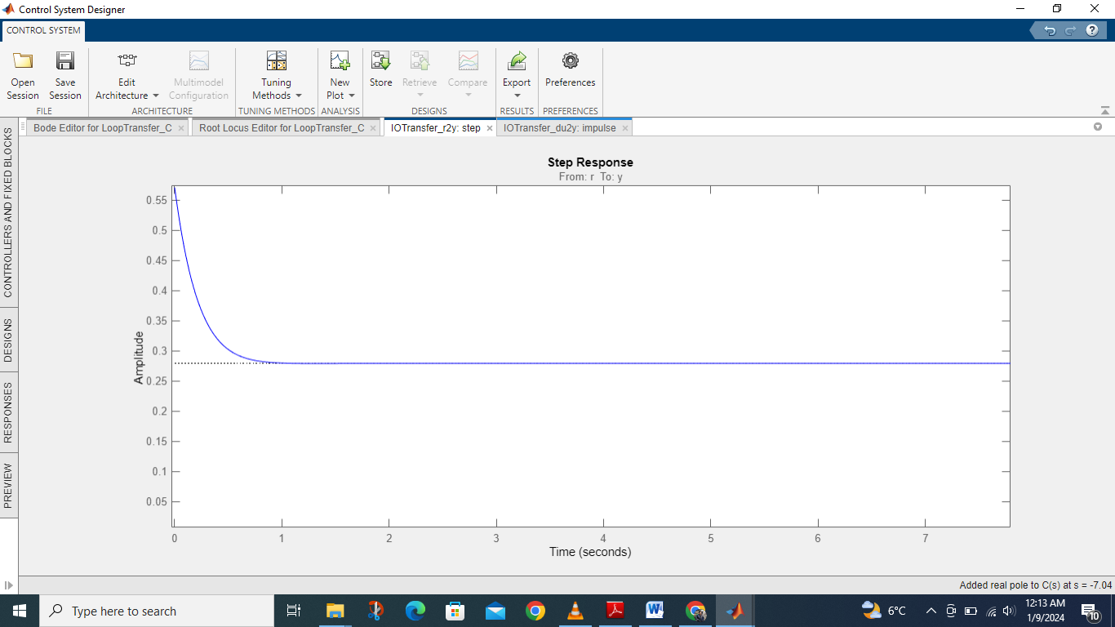

**The impulse response for k=2.**

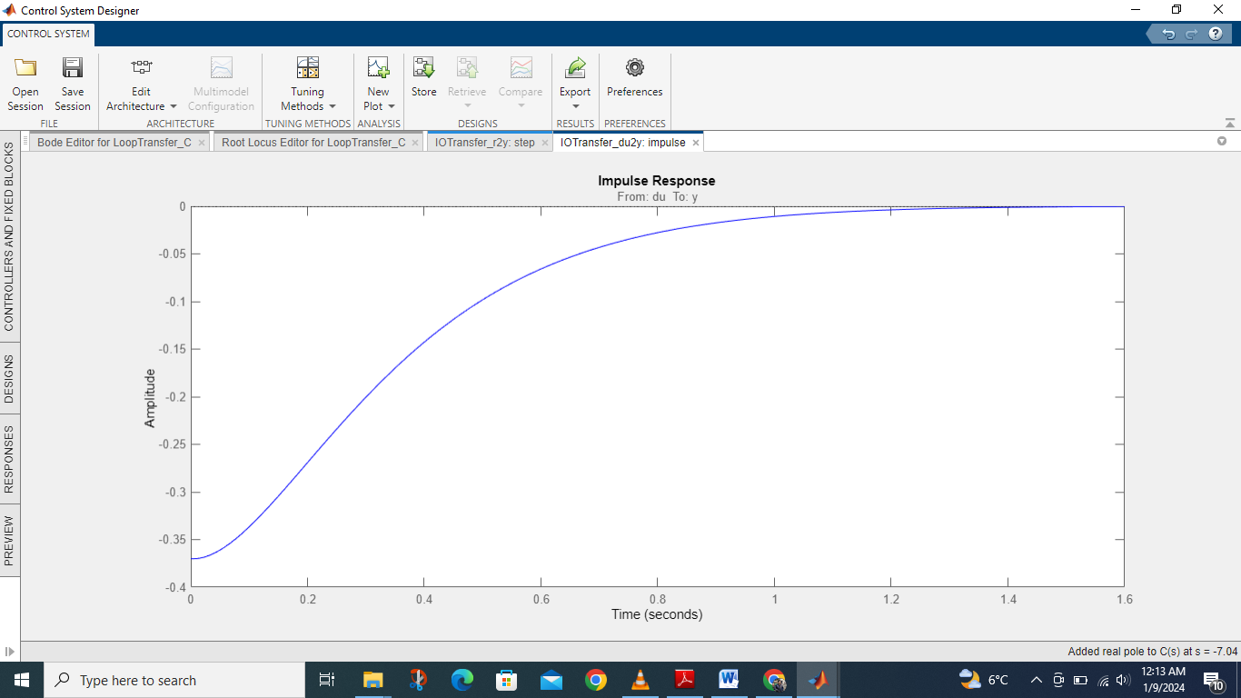

**Rise time and peak response for k=3**

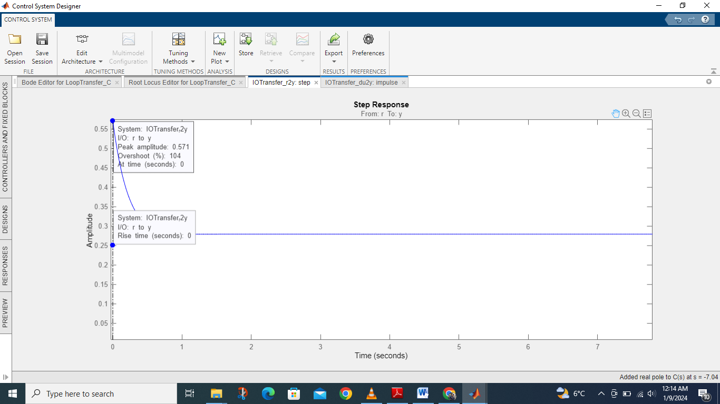

**Analysis**

* **Stability:** The system is stable for all points of k i.e. k = **-∞** to +∞
* **Breakaway Point**: 1.6
* **Break-in Point:** 4.6
* **Rise Time:** 0
* **Peak Response:** 0.571

**Conclusion:**

Through root locus we can find the stability of a system. It also shows that at which points the system will be stable and which point the system is unstable. Root Locus also shows rise time and peak time. It also inform about maximum overshoot.